GPS Tracking Module with Dead Reckoning
Sandia National Laboratories Clinic

Jim Bullough
Trevor Meier
Bobby McNeal

INTRODUCTION
For the 2008 Sandia National Laboratories clinic, the building of a tracking device was started. This paper will discuss what has been accomplished, how it was accomplished, suggestions for the next team working on the project, and what still needs to be accomplished.

This paper is broken into three sections. In Part 1, Bobby McNeal discusses the different components used for the tracking device and how they were selected. In Part 2, Jim Bullough discusses how he created the printed circuit board using the “Eagle” Printed Circuit Board software. Jim also discusses and offers advice on how to use this software. Finally in Part 3, Trevor Meier will discuss the methods of programming the Microprocessor. He will also go into how his programs were created and tested.

PART I – CHOOSING THE PARTS

1.1 ABSTRACT
A tracking system that we are trying to build for Sandia National Laboratories was the goal of our senior thesis. In developing the system we had design requirements set by the company since it had to be compatible with other products made by them. The major parts chosen were: a GPS to track position; accelerometer and compass to provide a dead reckoning approach if there is no GPS signal; and a microcontroller for communicating with each other and running the algorithm. The parts were placed together and a printed circuit board was made.
1.2 INTRODUCTION
Sandia National Laboratories uses technology to do applications for the government. They want to keep track of where a piece of equipment is and not go to places it shouldn’t or be tampered with by someone other then the intended user. We are designing a system to track where theses products are, and the path they have taken to get there.

Sandia uses a stack of boards where each board has its own functionality but can communicate with the other boards in the stack. Some boards include: a power board that regulates power for the others in this stack of boards; a data storage board; a board for communication; and various sensor boards. We are making a sensor board that is compatible with Sandia’s boards.

1.3 DESIGN REQUIREMENTS
In designing a product to be compatible with Sandia’s stack of boards we had to meet several requirements. The size requirement for our board was 38 mm by 32 mm and a spacing of 5mm between boards. This spacing allowed for parts less then 1.5 mm to be place on the bottom side of the board and all parts should be less then 3 mm on top. Some of the parts could not be found that meet the height requirement so the board we designed must be on the top of the stack.

In addition to the size requirement we also needed to have low power. The device runs off two batteries and so the current drawn from the batteries should be minimized so the batteries are not drained too quickly. Power cycling components that have a higher current draw is required to have lower average power consumption.

1.4 COMPONENTS
The size and required power were the main considerations in choosing parts for our design of a tracking system. Most parts were chosen by us but some components were specified by Sandia for compatibility with their stack. The major components include GPS, accelerometer, compass, microcontroller, and memory. Some of the parts required to connect to the stack and for getting data include: a mini USB to connect to a computer; a chip to transfer data from the microcontroller to the USB; two connections to be placed in the corners for the bus between boards; and a device to program the microcontroller.

1.4.1 Microcontroller
For the microcontroller we decided to go with the MSP430F1611 from TI. This microcontroller includes an ADC. Two serial communication busses (I²C, UART) are used for transferring data between components. This microcontroller has a clock that is used for the board and runs at 8MHz. The current for processing information is 330μA while its sleep mode is at 1μA. The size is relatively small at 12.2mm by 12.2mm by1.45mm. The I²C is used for communication over the bus between boards in the stack and also between components on our board. We use the UART for sending data to a computer through the USB. Figure 1 shows a rough diagram of how all of the components will connect to each other.

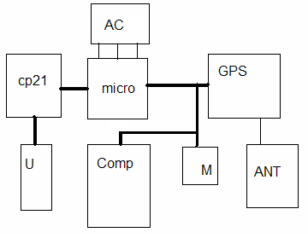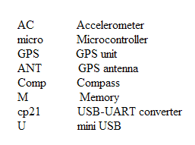
Figure 1. Major parts used and connections

1.4.2 GPS
The GPS is the major part for finding out where we are. It is also the biggest part at 26mm by 29mm. The GPS is actually a PCB board Nemerix’s NB2030 itself as seen in figure 2. The current of this device is 35mA but it can be turned off to save power. By turning it off for 10 minutes and receiving data for 10 seconds can give an average current of 1.67mA. The device has a cold start of 35s required when the device is first turned on or reset in order to create a database of available satellites. A hot start of 3s is for coming out of sleep mode and when a link with satellites has already been established and fairly fresh.
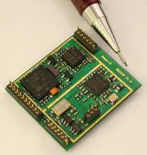
The GPS uses NMEA protocol to send information. This pre-made GPS module was chosen because it is the smallest, lowest power, and quickest turn on time that we could find.

Figure 1.1

This module requires four connections to our board. One is to connect to an antenna for which the GPS provides power to. The other connections are for receiving information and also to program any other program desired. Using the GPS we can get a fix on our latitude and longitude. Also storing the information and using speed and heading to interpolate the position if the GPS looses signal or needs to be shut down to save power.

1.4.3 Accelerometer
In choosing components for when the GPS is not giving us our location then we need to know the direction traveling and any change in speed so we can determine our

new location. A three axes accelerometer, the ADXL330, was chosen to find out how the speed is changing in every direction. These 3 outputs are analog outputs while the rest of our PCB is digital. The microcontroller is able to convert these through an ADC. The size is 4mm by 4mm by 1.45mm so it can fit on the bottom of our board. This device draws about 320μA of current when active. This device will probably be on whenever our board is moving and will be used to determine if the board is moving.

1.4.4 Digital Compass
A digital compass is used to determine which way the board is facing. The compass outputs an angle that corresponds to how many degrees between the front of the chip and magnetic north. The compass is HMC6352 from Honeywell. The size is 6.5 x 6.5 x 1.5 mm³ and will connect to the microcontroller through an I²C connection. This device requires 1mA in active mode and 1μA in sleep mode.

1.4.5 USB Device
To get the data off of the board, we put a mini USB device onto the board. The USB can provide an alternate power source when plugged in to reduce the power drawn from the batteries. Silicon Labs has a chip that converts a USB signal into one that can be sent over a UART connection. This chip CP2103 is used to give a regulated 3.3V that is used as a second power supply for our devices. It is connected to the microcontroller though the UART connection and to the USB. This chip can provide up to 20mA of current which should be enough for most of the parts. The CP2103 is about 5x5x.9 mm³.

1.4.6 Other Components
In addition to these major components other parts were used to improve functionality. Since we have two sources of power, the batteries regulated to 3.3V and CP2103 chip, we have a switch that can be flipped when the board is plugged into a computer so the batteries are not drained. A voltage regulator is also on the board to regulate the voltage coming through the common bus. To store all of the information 1MB of flash memory was placed onto the board so we don’t have to rely on data storage in the stack of boards. This is so we can be fully functional instead of requiring certain boards. A programming header set by Sandia was also used so the microcontroller could be programmed after soldered onto the board. To complete the list of products diodes, capacitors and resisters were used as directed in the data sheets of the individual components

1.5 Discussion
In looking at components the power was an issue. Some rough estimates with cycling the components will result in about 2-4 mA of current. Originally we were going to use 3V for Vdd but this was the minimum voltage for some parts so we decided to go with 3.3V. The specific parts that were ordered were from Digikey and those that could be bought individually and were in stock. All parts were chosen to be surface mount parts to make it a little easier in laying out the board, so we would not need to worry about drilling a hole where a part on the bottom might be placed.

Originally there was a gyroscope but in the process of putting all the parts together we realized that all of the parts needed were difficult to fit together and make all of the connections. The gyroscope would have been used to give a direction of travel and we figured that the compass and accelerometer would give us the same information. The gyroscope used more power then the compass and was larger so we dropped it from our design to allow for the necessary parts.

1.6 Conclusion
In designing a tracking unit the right components had to be chosen to fit onto the printed circuit board we designed. Even though the GPS we picked took up most of the board it was the lowest power, smallest, and shortest power up time we could find. By using an accelerometer and a compass we can make an algorithm to find out where the board is if we don’t have a GPS signal. By cycling the power of components we can reduce the average power used. It is estimated that the current would be 2 to 4 mA. The total power used at the 3.3V for Vdd will be about 7mW. In designing the board, if we had time we could have made our own GPS instead of the pre-made one we decided to go with to save on programming.

PART II – Design and Fabrication of Board
2.1 ABSTRACT
The design and fabrication of a 32x38 mm² GPS unit was done using “Eagle” Printed Circuit Board software. Preparation for designing the GPS unit involved choosing the separate components to be used, finding a manufacturer or company that had the parts in stock, ensuring that the parts did not violate the rules of the software or the minimum specifications of the project, and designing the footprints to put onto a printed circuit board. First, a schematic was made without consideration to space or performance, after which the board layout was designed. After several revisions and exchanging of parts in order to optimize space and functionality while assuring the circuit would still function as designed, the parts were routed according to the design of the schematic and a number of Gerber files were prepared and sent to Sierra Proto Express to build and assemble five boards that would be used to test.

2.2 INTRODUCTION
The task presented to the group was that of designing and manufacturing a GPS unit on a printed circuit board (PCB) that met certain specifications. The specifications were that it needed to fit on a board measuring 38 mm in length and 32 mm in height, be able to accurately measure the location of the board in the case that a GPS signal cannot be reached, and to operate with very low power consumption. The explicit purpose of this project was not explained in great detail, but it was made known that it was a sub-part of a number of different projects that would be incorporated together to fulfill a more comprehensive purpose.

This specific task presented was done by first brainstorming possible ways of calculating the location without the use of a GPS signal, researching and selecting different components and their datasheets at multiple manufacturing companies, designing and fabricating a PCB, and testing the board after fabrication. This report will talk specifically about the process of designing and fabricating the PCB.

The procedure of designing fabricating the board consisted of 8 main steps. This report will outline and describe the procedure for each of these steps in addition to some of the problems, tradeoffs, and optimizations that were made in order to reach greater functionality. The steps of design and fabrication that will be described in detail throughout this report are as follows:
- Create a Symbol for each component
- Create a Footprint for each component
- Combine each Symbol and Footprint into a package
- Design Schematic
- Generate Layout
- Route Board
- Verify Rules/Matching
- Generate Gerber Files
As a precursor to designing the board, it was necessary to brainstorm about the functionality of the chip and to decide on which parts to incorporate on the board. These parts were changed throughout the course of the project for reasons of improved functionality, smaller size, lower costs, lower power consumption, and part availability at the different manufacturing companies. Most of this research was done on digikey.com where datasheets and manufacturer websites were readily accessible.

After researching different parts, the main pieces incorporated on the board were the GPS daughterboard, an accelerometer, a digital compass, and a microcontroller. Once these main parts were chosen, “glue logic” for interfacing the different chips were added. These parts included multiple capacitors, resistors, Zener diodes, a switch, a USB chip, a USB connector, a program connector, a memory chip, and all the routing between parts. Once the collective area of these parts was calculated, space turned out to be a prominent problem and a gyroscope that had previously been incorporated was removed along with its related glue logic. This was done in hopes that the accelerometer and the digital compass would provide an accurate enough location in the absence of a GPS signal.

2.4 EAGLE SOFTWARE
The software used in designing this board was the Eagle Printed Circuit Board Software. It was a freeware version that allowed for the design of a 100 x 100 mm² 2-layer board. With more hindsight, it would have been wise to buy the licensed software in order to incorporate finer minimum spacing and a 4-layer board. This would also make the board more uniform with the rest of the stack that engineers at Sandia are simultaneously designing. The performance may also improve with this these additional features.

The Eagle software was useful because it allowed for a visible representation of what the design actually looked like and a more precise estimate of whether the components on the board would fit or not. It also gave insight on which of the I/O pins to use on the microcontroller. There were numerous I/O pins on each of the four sides of the Microcontroller, and knowing where the glue logic and other components on the board were in relation to the Microcontroller helped in knowing which I/O pins to use.

2.5 DATASHEETS
The guides that were used in designing the symbols and footprints were the datasheets of the individual components. These came in lengths as short as 1 page for the Antenna Connector to as long as 70 pages for the Microcontroller. Each component had 2-6 options for different packages with slightly different features, so it was important to make the correct footprint for the correct component. The criteria used in choosing these parts were power consumption, space, height, and availability. Each part had to meet the requirements for each of these criteria before being selected for the board. This report will refer to data extrapolated from the datasheets throughout.

  - PROCEDURES IN EAGLE
This section is intended to help the next clinic group understand and use the eagle software. By follow the steps below, you will be able to create a PCB.

Step 1: Create the Symbol
Creating the symbols in Eagle was fairly simple. A frame was created, pins and pin names as seen on the datasheet were added, and a label for simplicity was added. This was done for each of the parts on the board. Two examples of these symbols are the diodes and the switch chips that are shown in Figures 1 and 2 below.

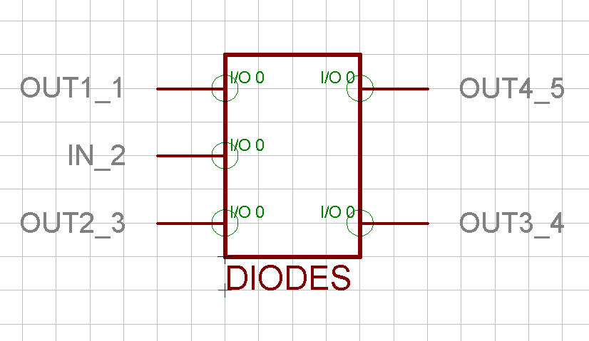
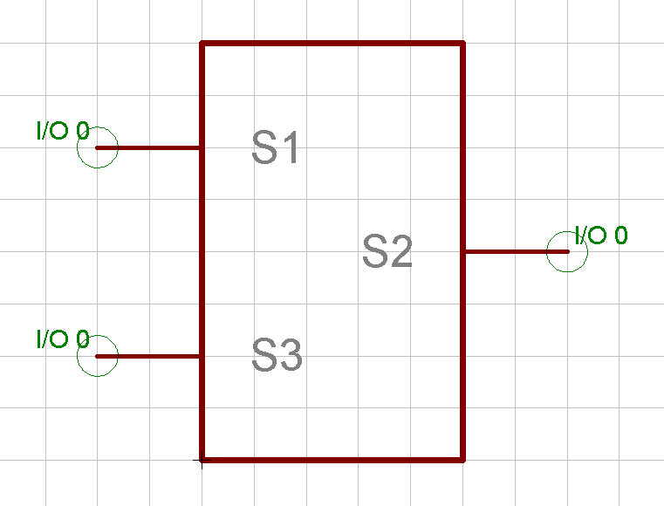

Step 2: Create the Footprint
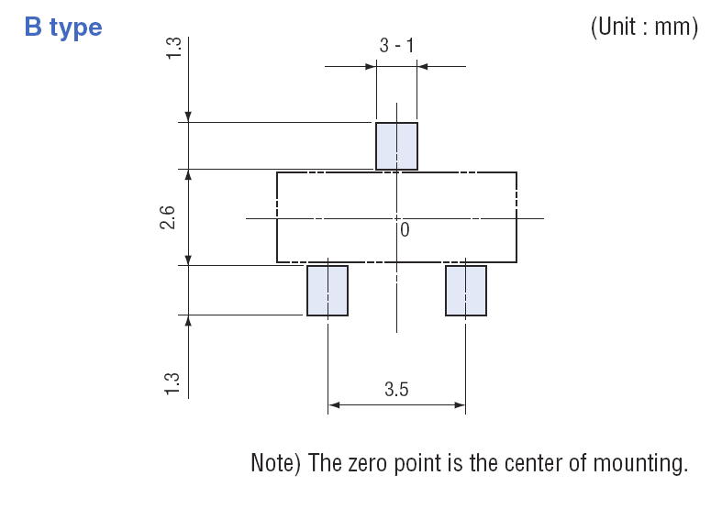
Creating the footprint was similar to the symbol, but required more precision. While errors on the symbol were permissible because nothing needed to be done to scale, the footprints needed to be within 0.3 mm for most of the parts. Each of the datasheets contained a blueprint that gave an idea of how to orient the pins of each of the parts. One such blueprint is shown in Figure 3 below.
This is the footprint layout on the Switch datasheet. This gives the dimensions of the package as well as the pins that will need to be soldered.

The pins are called surface mount devices (SMDs) and are placed in Eagle by typing the following command in the command window:
>SMD length width ‘name’
Where “length” and “width” are in grid units and the “name” should be the same name that was given to the pins in the symbol orientation. The SMDs are then placed in the same orientation as the datasheet making sure to match up the symbol and the footprint in their respective orientation. It was also important to change all the settings before doing this to mm instead of inches. The default setting for the program is inches, while the datasheets were usually given in mm. It was also important to know beforehand if the component was going to be put on the top or the bottom of the board. This determined which type of metal to use for the SMDs. It also determined whether or not to switch the orientation of the pins. The footprints for the diodes and the switch are as shown below in Figures 4 and 5. The Diode is on the bottom of the board and the Switch is on the top.
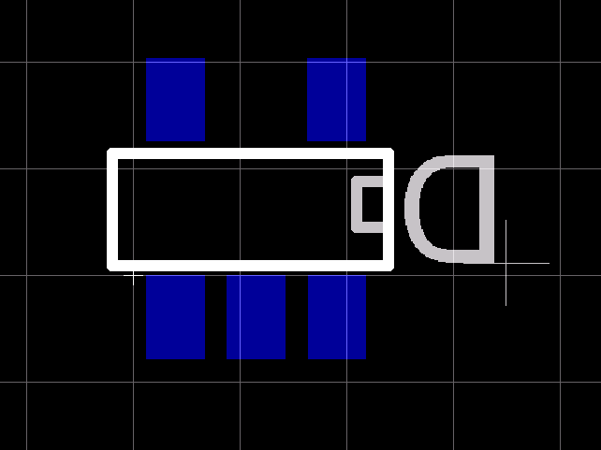
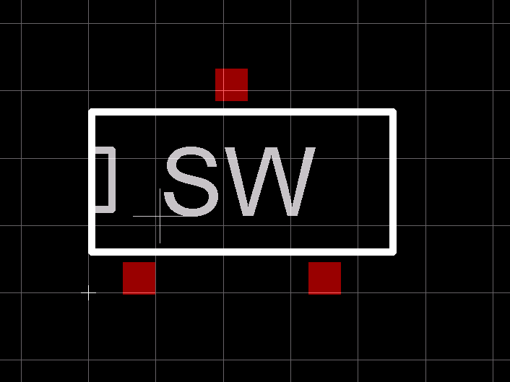

Step 3: Combine the Symbol and Footprint into a Package
The actual component that is used in Eagle for designing the overall schematic was a package. This is a combination of the symbol and footprint where the pins of the footprint and the symbol were connected. This allows the user to first design a schematic and to generate a board after fact without having to do them simultaneously. It also greatly reduces potential discrepancies between the schematic and the layout of the board.

Step 4: Design Schematic
This part was actually done for the most part before actually touching the Eagle software. Interfacing the parts together was done in the brainstorming at the very beginning of the project. This consisted of about 5 different lists of component names and pins of the microcontroller to which each of the different components was connected. The Eagle software served in this to provide a more visual representation of the schematic and allowed for easy editing. A screenshot of how the schematic appeared in the software is shown in Figure 6 below.

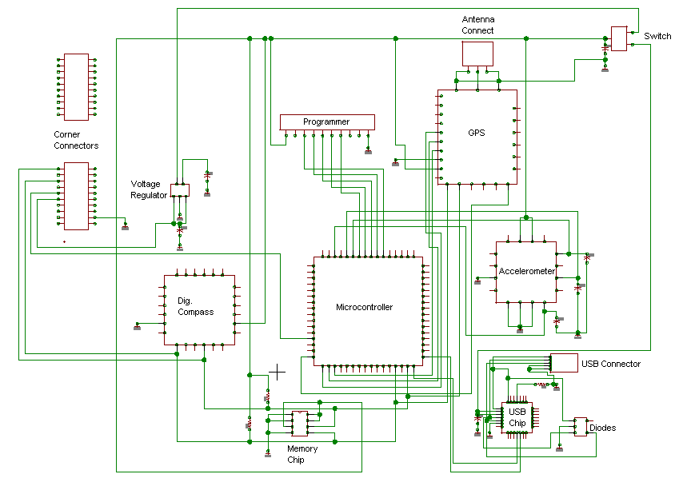

Step 5: Generating the Layout
After designing and routing the schematic, the layout of the board was generated and the parts were rearranged to fit on the 32x38 mm² board. Eagle indicates where each pin connects with thin yellow lines called “air wires”. These are a visual tool in knowing how to orient the different components. This is a point at which many of the I/O pins were changed in order to more favorably fit the components on the board.

One useful tool in the pre-routing state is to place top and bottom metal in all the places that routing is not permitted. One such example is where the USB connector on the right of the board is located. A screenshot of the pre-routed board will be shown below in conjunction to the final board layout.

Step 6: Routing the Board
The “auto route” function was used when routing the board. After all the components were placed and there appeared to be room for all the pins, contacts and their wires, the auto route function could be called. Before the board could be routed, however, the design rules needed to be set. These could be found at Sierra Proto Express’s website. The minimum spacing was 0.006 inches between metal and wires or 0.1524 mm. The wire width was also halved and the drill size was left at default. The orientation of top and bottom metal routing was then chosen, and the board was ready to route. At this point, the Eagle software would crank through the routing of the components. After a few attempts and rearranging the parts, the board was able to get about 95% routed. The remaining wires needed to be routed manually. Once the board was 100% routed, the final product looked like Figure 7 as shown below.

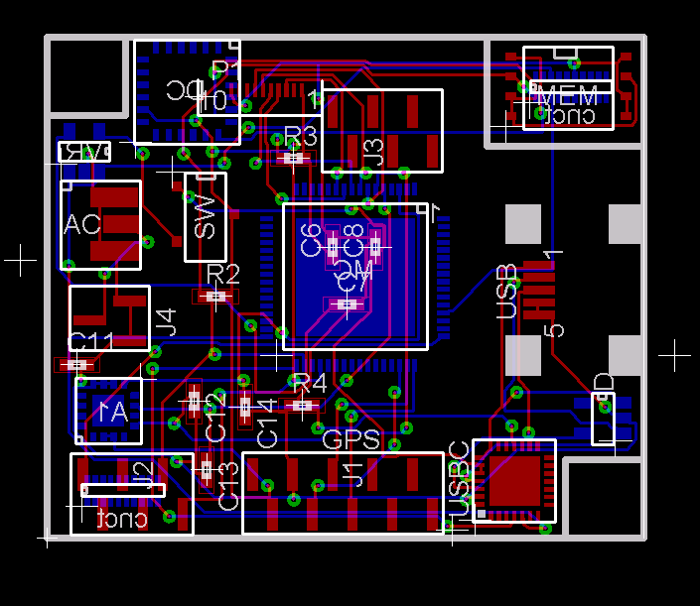
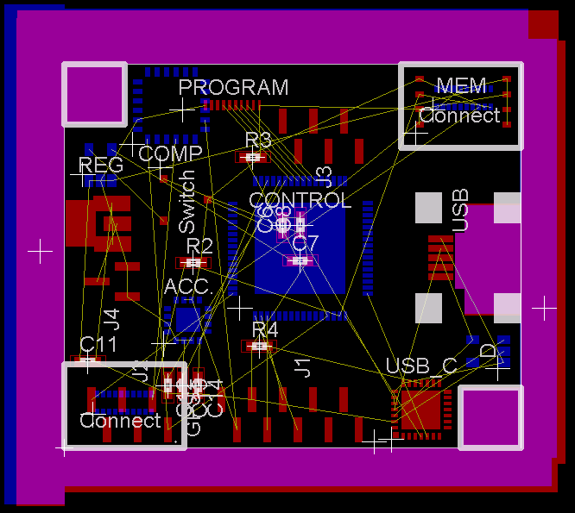

Step 7: Verify Rules/Matching
Because wires and metal with different potentials can be only so close together without affecting the functionality of the other, there are some minimum spacing rules that need to be enforced to ensure functionality of the chip. One such example is that drill holes cannot be overlapping with routing wires. A test that is run to assure than no rules are being broken is a DRC (Design Rules Check). After this is complete and any problems are fixed, a matching check is then run between the schematic and the board layout. This is called an EFC check. If there are errors in these two verification simulations, troubleshooting then takes place until the problems are fixed. This typically involves changing the schematic and “ripping up” wires on the board. The command to do this in the board editor is:
>RIPUP
After typing this command, whichever wire/net is clicked will turn into an air wire ready to be rerouted.

Step 8: Generating Gerber Files
Once all the problems are fixed, and the final board to be manufactured is generated, multiple Gerber files need to be generated and sent to a proto board manufacturing company. The table below contains the type of Gerber files that were generated using the Cam Processor in the Eagle Software:
Table I: Gerber Files Sent to Manufacturer

Description | Layer Name | File Type
Superimposed Layers | All Layers | .brd
Top Metal/Wires | Top Copper | .cmp
Bottom Metal/Wires | Bottom Copper | .gpi
Top Outlines/Labels | Top Silkscreen | t.plc
Bottom Outlines/Labels | Bottom Silkscreen | b.plc
Top Contacts/Vias | Top Soldering | .stc
Bottom Contacts/Vias | Bottom Soldering | .sts
Drill Info | Drill Size | .drd
Part List | Bill of Materials | .bom

Each file represents a different layer on the board. The company that manufactures the boards (Sierra Proto Express) does it one layer at a time and uses these file names as a guide. If the Silkscreen layers are well indicated, and all the footprints are correct, the company can also order the parts that are contained within the book of materials. If requested, the company can even mount/solder the parts onto the board so it doesn’t have to be done manually. The final product will hopefully look like Figures 8 and 9 shown below:

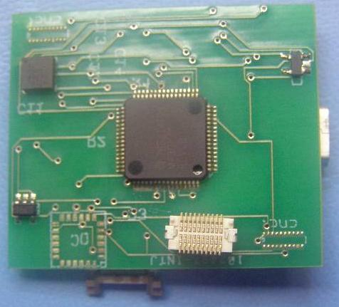
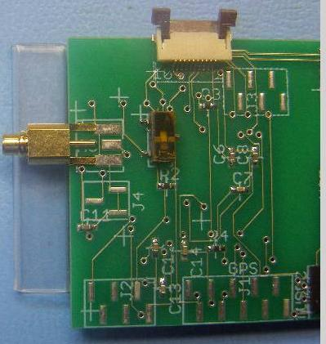

2.4 DISCUSSION
After the board is complete, there are a couple things with hindsight that could have been changed to improve the performance of the board and possibly optimize the space to make room for additional components.

The first thing that could have been done with more hindsight was to use a 4-layer board instead of a 2-layer board. This would have permitted two middle layers to be ground and supply planes. Ground and supply planes would eliminate the need to route any ground or Vdd wires on the top or bottom layer. In addition to saving space, these extra layers would also decrease the power consumption through the wires and decrease the inductance of the wires when a signal is being transmitted.

Another optimization that could have been made would be to increase the thickness of the ground and supply wires. While this method would not save space, it would possibly improve the performance of the board by decreasing wire inductance.

One such optimization was done by adding coupling capacitors at several pins. This could have been further improved upon by placing the capacitors even closer to the actual components. This would allow the supply wires to take current from the charged capacitors and thereby decrease the wire inductance and improve the performance of the circuit.

Another way to save space would have been to set the minimum spacing to be smaller. This would require a better manufacturing package, but is nonetheless available for a higher price. The 0.006 inch minimum was chosen because it seemed adequate for the given project. If a Gyroscope were to be added, however, it would probably be necessary to get better minimum specifications.

2.5 LAYOUT RECOMMENDATIONS
The Eagle PCB Software contains a manual that shows some of the basic steps to design the footprints, symbols, schematics, and layouts. This report also explains those steps in quite a bit of detail. A couple of things worth noting when using the software for the 1st time:
Do the Layout as a group of two or more: Having two sets of eyes will greatly reduce the chance of getting a defective board from the manufacturer. The next error could have easily been caught if there were two people who knew how to use the Eagle Software. The Eagle software defaults to whatever computer’s hard drive that it is installed on, but you can change the directory that it is reading from in the “Control Panel” by selecting Options and then choosing Directories where you can change the path name of ALL 6 of the directories available. If you don’t change all 6 of them, you won’t be able to generate the files when sending it off to the manufacturer.
USB Connector: Make sure to redo this component. It is oriented backwards on the current layout. This is the primary reason that the testing section is so incomplete. Without a proper connection from the USB connector, it is impossible to diagnose the actual board. The USB connector provides the power and ground references, without which it will be impossible to get any other components on the chip to work.
Layout Grid: Make sure to set the grid to some increment of “mm” each time you open up the packages unless you are doing all your dimensions in inches on purpose.
Nets/Wires: When drawing the wires on the schematic, make sure to use the “NET” function instead of the “WIRE” function. The wire function will still work, but you will manually have to add the junctions when you connect wires together. The “NET” does it automatically.
Bill of Materials: Do this as you go. Keep a table of all the parts, descriptions, and digikey part numbers. Make sure everything is in stock, and that you are in touch with the company if it is a unique part that may not have 10,000+ in stock.
Generating the Files: There are a couple of tutorials online that help with this. I used one on Instructables.com that was very useful.
One Idea: Make a preliminary board that is a little bigger that you can test functionality. This would allow you to get good practice soldering some parts that may not have been soldered as well as make it easier to fix dimension errors early on. Do as much of this as you can first semester so that you can spend the better part of the second semester testing.

2.6 CONCLUSION
The design and fabrication of the board was an integral part of this project. It required an extensive knowledge of the planning that went into selecting the parts as well as planning for improved functionality of the board to be tested after the fabrication is complete. It also involved learning a new software (Eagle) in addition to applying different engineering concepts in the optimization and placement of different components. Although there are still several optimizations that could be made with more time, the current state of the final product should be adequate in testing and reaching functionality in the testing stages.

PART III – PROGRAMMING & TESTING
3.1 OVERVIEW
Sandia gave our senior project very little instruction on how this tracking device should be built. The only devices they mentioned were a GPS receiver, an accelerometer and a gyroscope. As everyone knows, a GPS receiver is the best method to track an objects path. A GPS device accurately retrieves the latitude and longitude of the current location of the device. This made a GPS receiver the perfect tracking device. They only problem with using GPS is that there will be times when a GPS signal is not available.
In order to compute current position when there is no GPS signal, a process called “Dead Reckoning” was used. Dead reckoning is the process of estimating one's current position based upon a previously determined position, and advancing that position based upon known speed, elapsed time, and direction. An accelerometer and a digital compass can be used in order to continue tracking the path of the device when no GPS signal is available. With these components, the direction and velocity was computed. This in turn was used to compute the device's latitude and longitude. This entire device was build on a small circuit board. A microprocessor was used to run the programming and to communicate with the GPS, accelerometer, digital compass and the memory chip used for storing the data. This device meet all of Sandia's requirements for tracking an object.
This section will be discussing how the microprocessor was programmed, how it was used to communicate with the other components of the tracking device, and how the programs were written and tested.
3.2 MICROPROCESSOR FEATURES
For this tracking device, a microprocessor with specific features was needed. Sandia recommended a microprocessor that had all the features we needed. The MSP430 microprocessor made by Texas Instruments was used. This particular microprocessor is a popular choice for low power battery operated applications and has a current drawn in idle mode as little as 1 micro amp. It also has build in ADC, DAC and USART, SPI and I²C communication buses.
3.3 MICROPROCESSOR'S COMMUNICATION METHODS
The MSP430 microprocessor is capable of using several methods of communicating with other components. In this section, these methods and the devices that use them will be discussed in detail. The first method that will be discussed is I²C.
3.3.1 I²C
I²C is a method of communicating between a master and a slave device. In our case the master device is the microprocessor, and the slave devices are the digital compass, the memory chip and the GPS module.
I2C used to bidirectional lines (as can be seen below in Figure 1). The SDA line is used to transmit data, while the SCL line is used to transmit a clock signal which is used to synchronize the master and the slave devices.
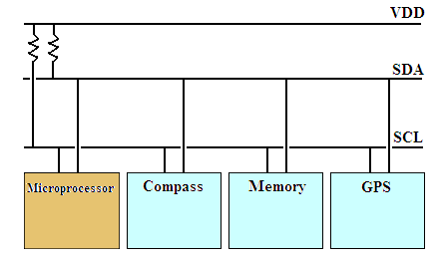
Figure 3.1
Each slave device has its own 7-bit address. To send a command to a slave devise, the microprocessor first sends a start bit followed by the 7-bit address of the slave it wishes to communicate with, which is finally followed by a single bit representing whether it wishes to write to or read from the slave. If the slave exists on the bus then it will respond with an ACK bit (acknowledge). At that point, the microprocessor sends a binary command.
Figure 2 shows how the microprocessor puts the digital compass in “Sleep Mode”. The command “S”, (which is represented in binary as 0101 0011) puts the digital compass in “Sleep Mode”. Examples of other commands the digital compass uses could be, “W” for “Wake”, which takes the compass out of sleep mode or “A”, to get the current heading which is sent to the microprocessor as a binary number.
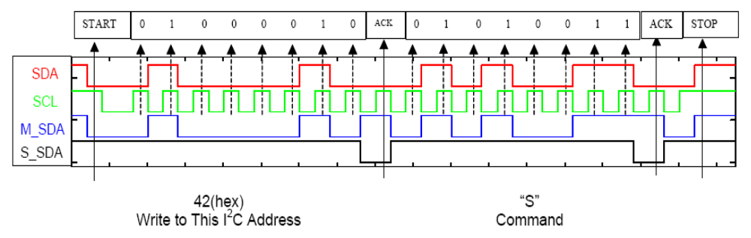
Figure 3.2
3.3.2 UART
To retrieve data from the tracking module and save it to a computer, a USB port is used. This USB port uses UART to communicate with the microprocessor as seen in Figure 3. UART uses a shift register to transmitted bits between sequential and parallel form at each end of the link. A shift register is a fundamental method of conversion between serial and parallel forms.
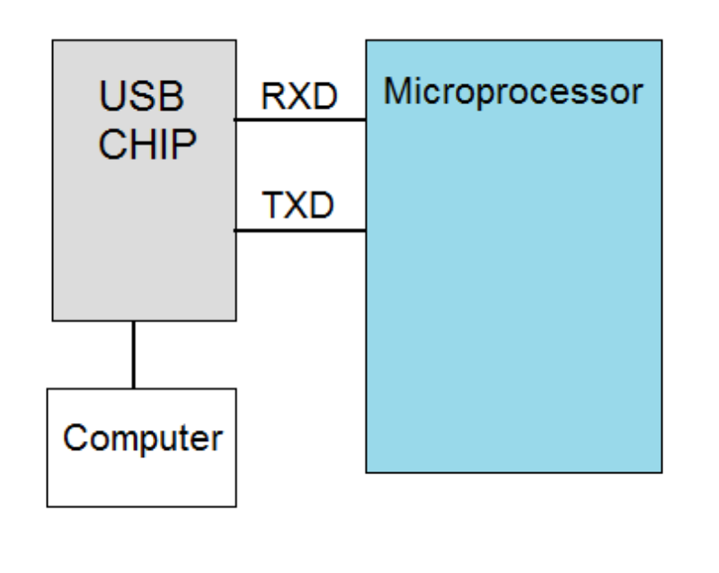
Figure 3.3

3.3.3 GENERAL PURPOSE I/O COMMUNICATION
The last method of communication between devices we used, was general purpose I/O pins. The X, Y and Z voltage outputs of the accelerometer are connected directly to their own general purpose I/O pins on the microprocessor as seen below in Figure 4. Using a built in Analog-to-Digital converter, these voltages are converted into a digital representation.
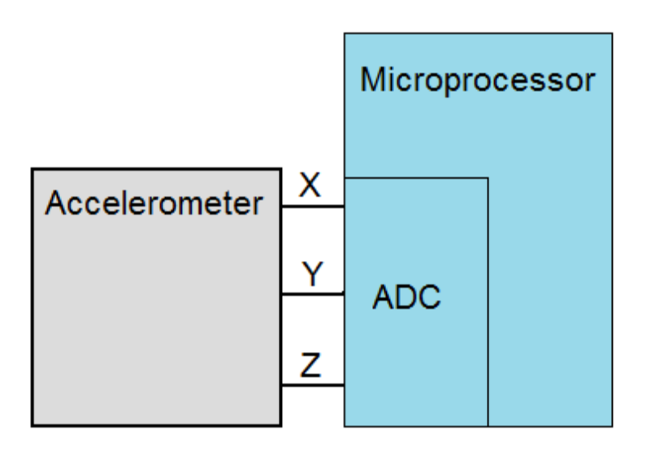
Figure 3.4
3.4 COMPUTING LOCATION USING DEAD RECKONING
When a GPS signal is not available, the latitude and longitude must be computed using “Dead Reckoning”. As mentioned previously, Dead Reckoning is the process of estimating one's current position based upon a previously determined position, and advancing that position based upon the current speed, elapsed time, and current direction.
The Dead Reckoning components are the accelerometer to compute speed, the digital compass to compute the direction, and the microprocessor to compute the elapsed time. Because an accelerometer only tells us the change in acceleration, it is also necessary to know the initial speed of the device. This initial speed may be the last know speed determined by the GPS, or it would be 0 if the device had yet to move.
Using the accelerometer, the accelerations in all three axis are sampled from the ADC about every 20 microseconds. Combining the X, Y and Z axis into one direction vector, the displacement from the last know location can be found by taking the double integral of this direction vector's acceleration. This is due to the fact that velocity is the change in position and acceleration is the change in velocity. Figure 5 shows this graphically.
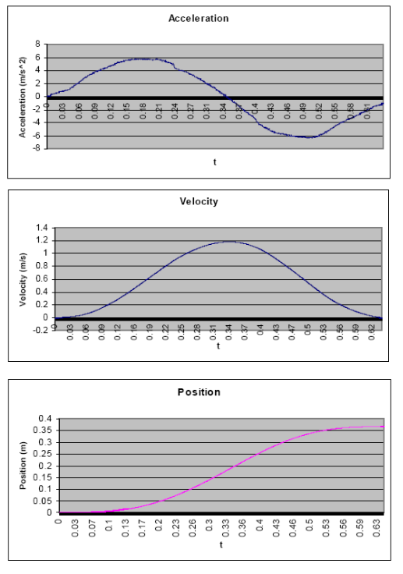
Figure 3.5
During this process of determining the displacement from the last know location, the digital compass is also being used to compute the direction of the device. It is important to note that when there is a GPS signal, only the GPS is being used.
This simple picture below shows how the accelerometer and digital compass work together to determine the current location.
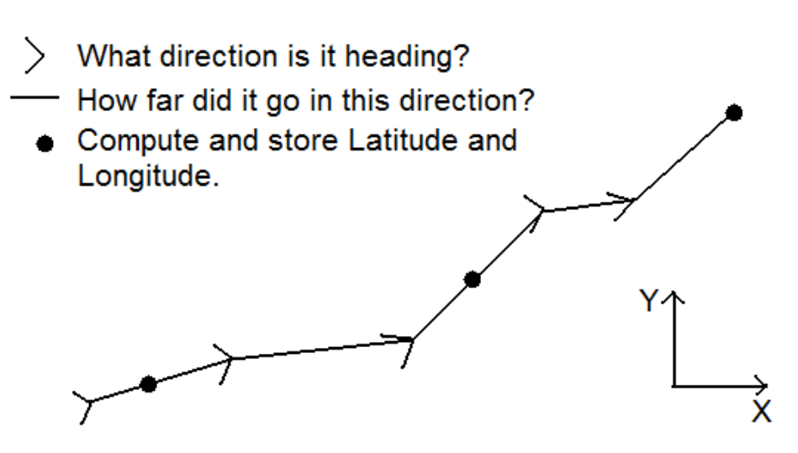
Figure 3.6
The direction of the tracking module is first determined and during a small increment of time, the distance traveled is then computed. The process repeats itself and periodically computes and stores the calculated Latitude and Longitude in memory. The Latitude and Longitude and computed using a simple formula that convert distance traveled in the X and Y direction into a new Latitude and Longitude. This type of formula is very common and can easily be found simply by searching the Internet.

3.5 PROGRAMMING THE MICROPROCESSOR
In this next section, the methods used to program the microprocessor will be discussed. To begin programming the microprocessor, the programming language first had to be decided. The MSP430 microprocessor has the ability of being programmed in several different languages. The C language was chosen due to the groups familiarity with that language.
There are two ways to program the microprocessor. The first method is to use a development board as seen in figure 7 below. The development board allows you to program the chip before it is actually installed. Software comes with the development board which allows you to compile, and upload the program to the microprocessor. Using this method, we were able to upload our program to the microprocessor and having an LED on the development board blink in a way that we could determine if our program was installed properly.
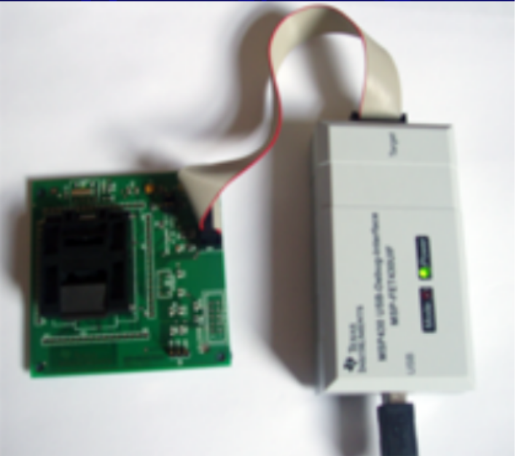
Figure 3.7
The second method of programming the microprocessor, is a 10 pin serial port built directly into the PCB. This port allowed direct communication with the microprocessor which allowed for program updates even after the PCB was completed.
3.6 PROGRAM FLOW CHART
The first step in writing the program used to run the tracking device, was to first decide on how the program would run. The figure below shows a flow chart of the program.
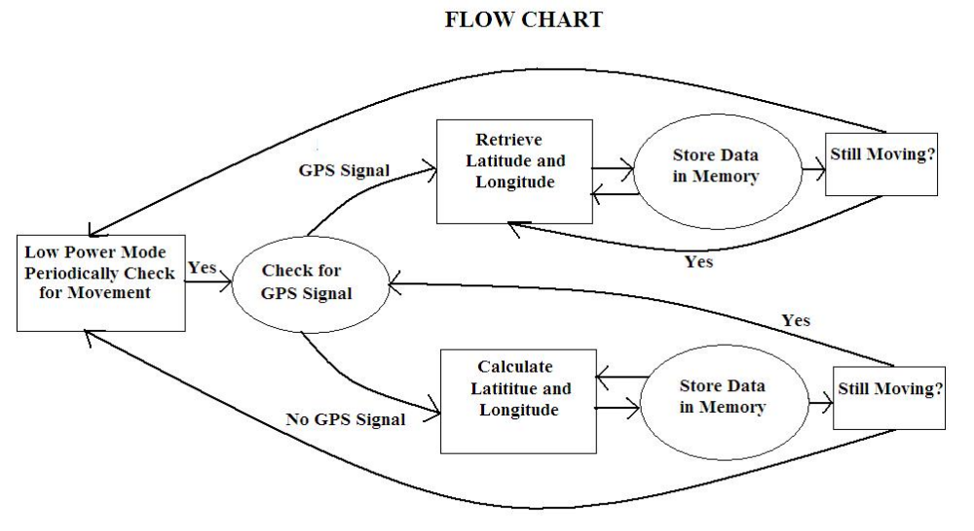
Figure 3.8
Following the flow chart, if there is movement, it then checks for a GPS signal. If there is a GPS signal, it will periodically retrieve the latitude and longitude and store it into memory. After a given amount of time, it will then determine if the tracking module is still moving. If it isn't, it will go back into low power mode. If it is, it will go back through this cycle again.
Now assuming there was movement but no GPS signal, the latitude and longitude would then be periodically calculated and stored into memory. Again, after a given amount of time, it will then determine if the tracking module is still moving. If it isn't, it will go back into low power mode. If it is, it will then go to this point where it checks for a GPS signal because a GPS signal is the preferred method in obtaining the current location.
Many of the programs that were used had already been written and were taken directly from Texas Instrument's website. These sample programs were used to build a function to compute the acceleration using the built in ADC, and used for building functions to communicate (using I²C ) with the memory chip, digital compass and the GPS receiver.
The one function that is still being written, is the function that computed the current location based upon the current acceleration and direction. In the next section, some of these programs will be discussed in more detail.
3.7 PROGRAM FUNCTIONS
As was previously mentioned, many of the functions that were used in programming the microprocessor, were already written and were taken directly from the Texas Instruments website. In this section, the method of understanding and manipulating these functions in order to use them will be discussed. As an example of this process, the ADC function will be discussed.
The ADC or the Microprocessor was used to convert the output voltages of the accelerometer to a digital representation. The first step in programming this feature, was to find a function that had the functionality close to what was needed. The following ADC function was found from TI's sample functions:
static unsigned int results[4]; // Needs to be global in this example
void ADC(void)
{
WDTCTL = WDTPW+WDTHOLD; // Stop watchdog timer
P6SEL = 0x0F; // Enable A/D channel inputs
ADC12CTL0 = ADC12ON+MSC+SHT0_2; // Turn on ADC12, set sampling time
ADC12CTL1 = SHP+CONSEQ_1; // Use sampling timer, single sequence
ADC12MCTL0 = INCH_0; // ref+=AVcc, channel = A0
ADC12MCTL1 = INCH_1; // ref+=AVcc, channel = A1
ADC12MCTL2 = INCH_2; // ref+=AVcc, channel = A2
ADC12MCTL3 = INCH_3+EOS; // ref+=AVcc, channel = A3, end seq.
ADC12IE = 0x08; // Enable ADC12IFG.3
ADC12CTL0 |= ENC; // Enable conversions
while(1)
{
ADC12CTL0 |= ADC12SC; // Start conversion
_BIS_SR(LPM0_bits + GIE); // Enter LPM0, Enable interrupts
}
}
#pragma vector=ADC_VECTOR
__interrupt void ADC12ISR (void)
{
results[0] = ADC12MEM0; // Move results, IFG is cleared
results[1] = ADC12MEM1; // Move results, IFG is cleared
results[2] = ADC12MEM2; // Move results, IFG is cleared
results[3] = ADC12MEM3; // Move results, IFG is cleared
_BIC_SR_IRQ(LPM0_bits); / / Clear LPM0, SET BREAKPOINT HERE
}
Once a function was found, the next step was to understand how it worked. Using a datasheet for the MSP430 microprocessor, the different commands that are used are deciphered. For example the _BIS_SR(LPM0_bits) command, puts the microprocessor in sleep mode. The next step was then to manipulate the sample function to perform the task that was needed.
In this ADC sample function, you can see that it converts four pins of the microprocessor into a digital representation. For our tracking module, we only had three voltages from the accelerometer that needed an analog-to-digital conversion. So, the first step was to then change the global variable from results[4] to results[3]. The sample function initiates four pins to be included in conversion. The command P6SEL = 0x0F initiated these four pins. The 0x0F is the Hexadecimal representation of the binary 0000 1111. The “1111” represent which pins would be used. In this case, pins 6.1, 6.2, 6.3 and 6.4 were used. For our circuit, only pins 6.1, 6.2 and 6.3 were used. The command thus became P6SEL = 0x07 which is the Hexadecimal representation of 0000 0111. Only a few other minor changes were made to this function in order to get exactly what was needed.
The same steps were taken in writing functions using I²C to communicate with the memory chip, GPS receiver and the digital compass. Many of the other functions needed to compute latitude and longitude were already written and were easily found on the Internet.
One program that needed to be created from scratch, was the program for computing the distance traveled using the acceleration measurements. As mentioned previously, the distance traveled can be found by double integrating the acceleration. To compute the total distance travelled, a program first needed to be created that took the double integration of acceleration data. The accuracy of this program would be determined by the time increments between the acceleration measurements.
Creating the program was pretty straight forward. What was not known was:
- How often should the acceleration be measured?
- How does the time between measurement effect the error in distance?
- What can be done to improve the error?
Using Matlab, the following double integral program was created. This program will need to be changed into the C language, and may need to be modified in order to receive the acceleration data in real time.
function answer = trevorsDoubleInt(a,b,n,func)‏
h=(b-a)/n;
x=a:h:b;
L = ceil(n/4)-1;
f = inline(func);
% Integrate the acceleration
for k=1:n/2
f0=f(x(k*2-1));
f1=f(x(k*2));
f2=f(x(k*2+1));
s(k)=f0+f1+f2;
end
s=s*2*h/3;
% Convert this into a velocity matrix
v(1)=s(1);
for k=2:length(s)‏
v(k)=v(k-1)+s(k);
end
% Integrate the velocity to get distance
d=0.0;
for k=1:L
f0=v(k*2-1);
f1=v(k*2);
d=d+(f0+f1);
end
% Total Distance
d=d*4*h/2
By creating this program in Matlab, we were able to test different sample rates at different accelerations. The results below show how the acceleration effects the error of the double integration. This error is shown in how many meters it is off each second.

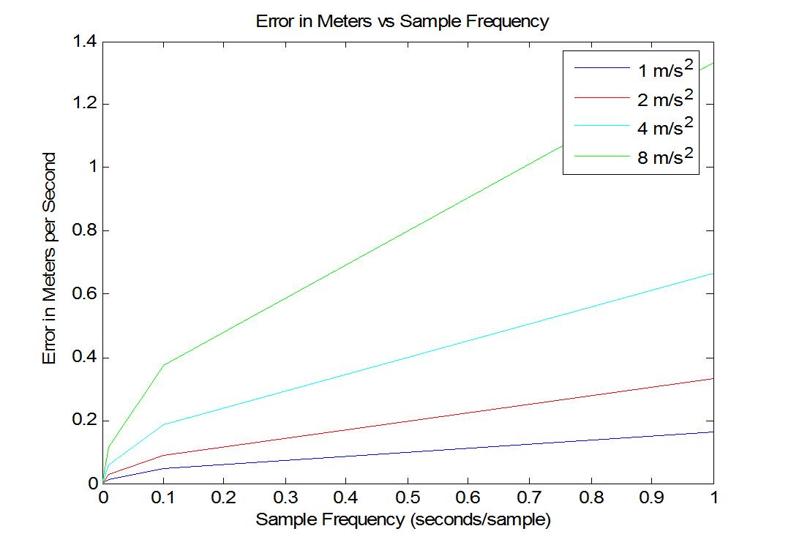Figure 3.9
From the figure above you can see that as the acceleration increases, so does the integration error in meters each seconds. You can also see how this error decreases with an increase in acceleration samples per second.
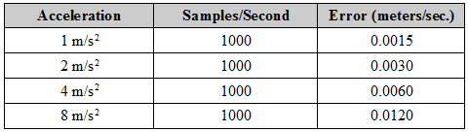
Table 3.1
You can see from the table 3.1, that at 1 m/s², a sampling rate of 1000 samples per second gave an accuracy of about 99.98% which means after 1000 seconds, the distance travelled would only be off by 1.5 meters. It also used much less time to compute than the higher sampling rates. For example, if you were to sample the acceleration at 10,000 times each second, the integration would actually take longer to compute than the time for which the acceleration was integrated. For these reason, a sample rate of 1,000 times each second was determined to be adequate.
The problem was, as the acceleration increased, the accuracy decreased. From table 3.1 you can see that the error in meters each second doubles each time the acceleration doubles. In order to maintain an accuracy of around 99.99%, the following formula was used to compute the necessary samples per second needed:
Samples per second = 1000 * acceleration
This means, that in order to maintain an accuracy of 99.99%, the time increments between measurements needed to change with the change in acceleration. The figure below shows this visually. The blue lines represent acceleration measurements. At moments of greater acceleration, the acceleration is taken more often.
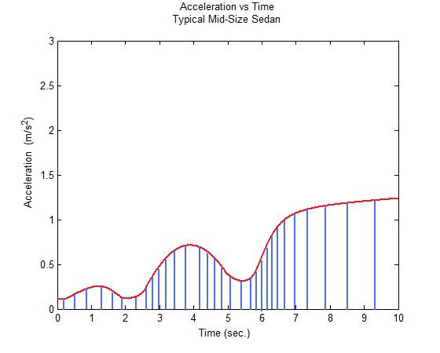
Figure 3.10
To view all the programming done for this clinic, go to the following website:
http://uofusandia.wetpaint.com
From there, go to the “Programs” page.
3.8 TESTING THE PROGRAM FUNCTIONS
Because the actual circuit had yet to be completed, most of the testing of the functions had to be done using the MSP430 development board and software. To test the ADC function for example, an LED was illuminated when a voltage of a value higher than an amount determined in the program was applied to one of the pins used for the accelerometer. Using this rudimentary method, the ADC function could be accurately tested.
To test other devices such as the memory chip or digital compass, the development software was used. This software allowed testing of the microprocessor to be done while installed on the development board. Although no devices themselves could be testing directly with the microprocessor, these devices could be simulated in the program.

3.9 PROGRAMMING RECOMMENDATIONS
The best method for learning how to program the Microprocessor, is to read the “READ ME FIRST” paper found in the MSP430 Development Tool box. Go to section 1.4 and follow the instructions for installing the software.
A problem with this installation will be immediately encountered due to an outdated device driver. This driver will have to be installed manually directly from the CD-ROM. In Windows, this can be done by right clicking the “My Computer” icon and selecting “properties”. Next, select the “Hardware” tab and from there, click on the “Device Manager” button. With the programming module plugged into a USB slot, find the corresponding device in the list. It should have a yellow question mark next to it. Right click the device and select “Update Driver”. From this point it is self explanatory. There is only one device driver on the CD-ROM and is really easy to find.
OVERALL CONCLUSION
We hope we have laid the ground work for the next clinic team. This is a challenging project and we recommend hitting the ground running. We currently have a website set up for this project and hope you will use it to keep your team organized and up to date.

We would like to thank James Bergstrom and Doug Gehmlich from Sandia for all there help and the opportunity to work on a exciting and challenging project. We would also like to thank Cameron Charles for all his help and guidance.

